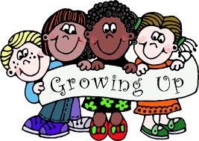
SRE
Why are girls taught about boys’ development and vice versa?
We believe it is very important for children to understand each other’s development. It helps to ensure that children are mindful of their peers’ needs and allows them to develop into sensitive, caring, compassionate individuals who understand the changes that boys and girls experience.

Authors
The Department of education recommends that all primary schools should have a sex and relationship education programme tailored to the age and the physical and emotional maturity of the children. It should ensure that both boys and girls know about puberty and how a baby is born – as set out in Key Stages 1 and 2 of the National Science Curriculum.

Your right to withdraw your child.
You may not withdraw your child from the parts of SRE covered in Science as these have, by law, to be taught.
You may, following discussion with the head teacher, request to withdraw your child from the SRE not covered in Science. In making this decision you should think carefully about:
- all the other children in your child’s class will have been taught this information and may well talk to your child about it, perhaps in the playground... and potentially mislead them or confuse them as a result. It may prove far better to allow experienced and sensitive teaching staff to teach your child in a progressive, developmental way that is grounded in research.
- The SRE in PSHE Education will concentrate on building self-esteem and teaching children how to enjoy healthy, appropriate relationships, improve self-esteem and self-confidence, and make healthy, informed choices. When viewed this way, it is hoped that SRE won’t be seen as contentious or a cause for concern, but rather as helpful.
Please speak to the head teacher before making any decision to withdraw your child. If you still plan to go ahead, your decision must be given in writing.

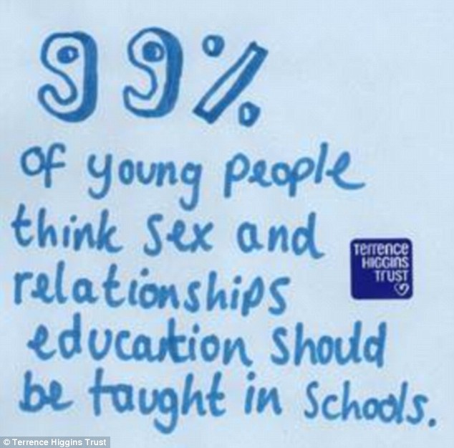
What will my child actually be taught?
By the end of each phase the pupils will learn:
By the end of KS1:
- the differences and similarities between people
- the biological differences between male and female animals and their role in the life cycle
- the biological differences between male and female children
- about growing from young to old and that they are growing and changing
- that everybody needs to be cared for and ways in which they care for others
- about different types of family and how their home-life is special
By the end of LKS2:
- the way we grow and change throughout the human lifecycle
- the physical changes associated with puberty
- menstruation and wet dreams
- the impact of puberty on physical hygiene and strategies for managing this
- how puberty affects emotions and behaviour and strategies for dealing with the changes associated with puberty
- learn strategies to deal with feelings in the context of relationships
- to answer each other’s questions about puberty with confidence, to seek support and advice when they need it
By the end of UKS2:
- the changes that occur during puberty
- to consider different attitudes and values around gender stereotyping and sexuality and consider their origin and impact
- what values are important to them in relationships and to appreciate the importance of friendship in intimate relationships
- about human reproduction in the context of the human lifecycle
- how a baby is made and grows (conception and pregnancy)
- about roles and responsibilities of carers and parents
- to answer each other’s questions about sex and relationships with confidence, where to find support and advice when they need it.
- learn some myths and misconceptions about HIV, who it affects and how it can and cannot be transmitted.
- about how the risk of HIV can be reduced
- that contraception can be used to stop a baby from being conceived
Why is SRE taught in schools?
SRE aims to supports children’s emotional development by educating them about relationships and emotions. It is tailored to the age, physical and emotional maturity of the children.
SRE is not a ‘one off’ event but an ongoing process of education which begins in nursery. From an early age children begin to learn about relationships and are taught how to express their feelings. SRE links with work in other subjects, such as science.
More than ever before, children are exposed to representations of sex and sexuality through the media and the social culture around them, so we need to present a balanced view of SRE.
Rates of sexually-transmitted infections (STIs) and teenage pregnancy in the UK are relatively high – as is the regret felt by young people after early sexual experiences.
Research shows that most parents say they want the support of schools in providing SRE for their children.
Research consistently shows that effective SRE delays first sexual experience and reduces risk- taking.
Surveys of children and young people have repeatedly told us that SRE tends to be “too little, too late and too biological”.
Our aims:
- To educate children about relationships, focussing on friendships, bullying etc. supporting children’s emotional development and improving self-esteem.
- To develop personal and social skills and a positive attitude to physical wellbeing;
- To help children grow up feeling confident about their emotional and physical health;
- To educate children about health issues and personal hygiene.
- To educate children about age-appropriate developmental issues, including puberty.
- To begin to give pupils an understanding of the issues that will prepare them for the challenges and responsibilities of emotional, moral and sexual maturity form a (faith) perspective.
- To promote pupils moral and social development and prepare pupils for the responsibilities of life, supporting them on their journey through childhood and adolescence to adulthood.

Our children learn about sex even if we don’t talk about it with them. Some of the things they learn are incorrect, confusing and frightening.
In a world where sex is used to sell things from food to fast cars and celebrities’ lives become everyone’s business, we should talk to our children to help them make sense of it all.
It is crucial that we support our children in feeling good about themselves and their bodies. At the heart of this, we work to ensure that children develop high self-esteem.

