[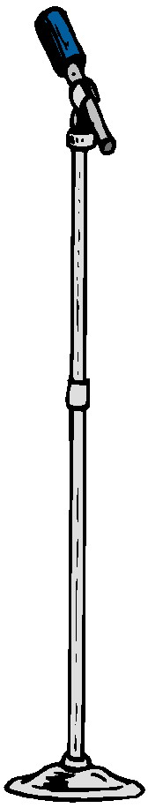](http://www.google.co.uk/url?sa=i&rct=j&q=&esrc=s&frm=1&source=images&cd=&cad=rja&uact=8&docid=tYdN56YKbYIy6M&tbnid=eWozAvIM8c9IqM:&ved=0CAUQjRw&url=http://sued51.wordpress.com/2013/03/15/my-first-poetry-slam/&ei=P1x6U_O3KJL07Aa6hoCQCw&psig=AFQjCNHddTST9564EMF0Zoe3MkwXRO0fDA&ust=1400614290676934)

**How it works:**

1. Children choose a piece of poetry of no more than 12 lines either from the selected list, one of their own choice or one they have written themselves. It does not have to be a complete poem!
2. They must learn their piece of poetry off by heart.
3. Children will perform their poem to their class. 12 finalists will then perform at the Summer Fair.
4. There will be prizes awarded to the winners and all finalists will receive a certificate.

**Please spend time enjoying the poetry with your child and supporting them in learning their piece. We look forward to hearing their fantastic performances!**

Summer Term 2 sees the return of Cookridge Primary School’s

**‘Poetry Slam’**

**Cookridge Primary**

**Poetry Slam!**