Dear Parents and Carers, 21st March 2025

Trip to Bridlington
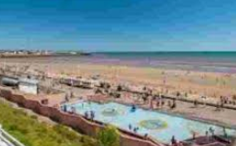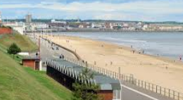

Our next topic is ‘Seaside’. We would like to take the children to Bridlington. Bridlington is a beautiful seaside resort on the east coast. The reason for the visit is to put into practise the knowledge the children will have acquired during this topic.

During the visit the children are going to visit the beach, lido and lifeboat station. They will be given the chance to paddle in the shallow lido, play on the beach and have an educational visit to the lifeboat station.

The children will be leaving school at 9.00am on Monday 9th June and returning approximately by 4.30pm. The reason for the delayed return to school is to ensure the children get maximum enjoyment and rich experience at the seaside.

The children will be required to bring a packed lunch, drink, change of clothes in a named back pack and named bucket and spade (optional). Children will be allowed to wear non-uniform on this day that is appropriate for the weather. Please ensure foot wear is appropriate for walking.
The cost of the trip is £20.00 and this will include the purchase of an ice lolly/ice cream. The cost for pupil premium children will be £10.00. Please pay via Parent Pay.

The Key Stage One team are looking forward to this exciting experience!

Yours sincerely,

Hannah Koopman
Key Phase Leader

